This is Avenham

1. Finding the gifts, skills and assets of the community of Avenham, Preston.
An asset based survey was carried out in Avenham area of Preston, Lancashire in April 2011. The purpose of the survey was to map the strengths, gifts and skills of the individuals that make up the community of Avenham. This was also an opportunity to evaluate the process of asset mapping in a diverse, urban, UK community, to inform future research projects and community development practices. The project was delivered as a partnership between CVS, UCLAN and Moving On Lancashire.

2. Avenham
Avenham is one of the areas that make up the Town Centre ward in Preston, Lancashire. The area surveyed consisted of certain streets based around the Moving On Centre, highlighted below
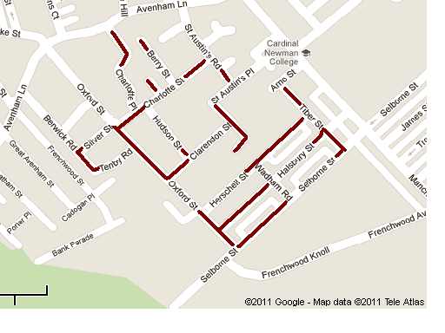
Moving on Centre
Avenham Park
Avenham is an area which is ranked amongst the 20% most deprived localities in the country (Indices of Multiple Deprivation, 2010). The 2001 Census showed that the wider area was ethnically diverse, with large numbers of white British population (62%) and Asian or British Asian (32%) making the significant components of the community. However, over the ten years since 2001 there has been significantly increasing additions to the community from European countries and this is likely to be shown in the 2011 census results, when published. The ward has a higher then average claimant rate for work related benefits, with 1 in 5 of the working age population claiming employment related benefits. Life expectancy is some 4 years less than the national average, and 3 years less than the Preston average.

Avenham is home to Avenham Park, which houses gardens, playing areas, walks and a wildlife garden. There are community centres and places of worship based in the locality, including churches, a mosque and a gurdwara. Schools, a Further and Higher Education College, Cardinal Newman College, and the City Centre are also within easy reach, with a range of retail outlets, services and other opportunities within a few minutes walk. There is also a large health centre on Avenham Lane, with health services onsite.

3. Asset based approaches to community development
The focus point of this research was to gather information regarding the assets, gifts and skills of the community rather than its needs. Generally community surveys and data collection focus on the needs of the community. This can have a dual negative affect; it asks the community to look at their community from a negative perspective, enforcing the view that the location/residents are deficient; it also, in terms of service delivery, encourages a model where community members become passive recipients of services, in what Cormac Russell calls, ‘the social services model’ (Russell, 2009) where services are delivered to fulfil particular needs identified in communities.

It is essential to balance needs based and asset based approaches in a practical way. By understanding the needs of a community, institutions and professionals can identify where resources may need to be channelled. However, in channelling these resources, better outcomes are likely to be achieved through development work modelled on asset based approaches, in that communities are more likely to engage with the process through ownership and empowerment (IDE & A, 2009). Asset based approaches concentrate on what the community want to offer as individuals or in unison, and what motivates community members to participate in their community. This begins by asking questions about what the community can do and what they want to do, rather than what they need.

4. What did we do?
Volunteer Community Researchers were recruited from UCLAN’s Community, Care and Citizenship foundation degree course. They were involved in each stage of the project, including planning, marketing, surveying and evaluating the research.

The team worked in pairs and visited households across the area, to complete surveys with residents. A blank survey is attached at Appendix A. This survey was adapted from the case studies in A Guide to Capacity Inventories (Kretzman et al, 1997). The survey was designed to be purposefully brief, so as not to inconvenience the residents.

The marketing of the project was done through text message, assisted by Contour Housing, which owns a significant number of the houses in the area. They were able to text all of their tenants using an internal system, informing them of the survey. There was also attendance at key meetings, such as Police and Communities Together [PACT], to inform people about the upcoming survey.

It was noted that as the project went on, more residents were aware of it and many responded better once they had heard about it. Many of those respondents identified that they had heard about it from other community members.

What’s in a name?
Rather then calling it an asset map, or asset survey it was decided that it would be called a community survey, so people would instantly recognise the purpose of the work being about community development. The survey included a script, outlining its purpose. As the researchers became more familiar with this they were able to adapt the information and present accordingly to the respondents. The researchers noted that initially many people were reserved in their responses and were sometimes reluctant to take part. The researchers often had to build a rapport with the individuals and then support them to participate in the survey by being clear about what information was needed and why.

The survey was carried out during the day on a Tuesday, usually between 10am – 2pm. This took place over 7 weeks, with additional Wednesdays being completed on some weeks. This may have meant that only certain groups of people were surveyed, e.g. Homemakers, retired and unemployed people.

5. What could we have done better?
This survey was delivered as a pilot project, to aid in the development of asset mapping throughout Central Lancashire. The project outlined a range of development areas in the methods used and these are outlined briefly below.

The best way to complete an asset map is by having the community map themselves. Originally, it was planned to have local officers, community workers and community members accompany the researchers throughout the survey. This was unable to happen due to time restraints and lack of links within the wider community. Some of the knowledge gained through the survey is lost when the external researchers leave an area (Kretzman et al, 1997). The community being part of the survey can aid it to become self managing and create community linkers and gappers, who bring people, ideas and motivations together and fill spaces where necessary.

It also became difficult to hand over the information to local groups due to data protection on one hand and the fact that many respondents did not feel comfortable with personal details being disclosed as part of the research. Therefore many of the respondents did not wish to have their addresses and contact details disclosed.

We have mitigated against this by putting on an event that enables the community to come together and receive feedback on the findings of the survey. They will also be able to find out how they can get involved in community activity, with specific invitation for those who took part in the survey. It will be based around the activities identified through the survey and enable people to sign up for or find out how to help organise activities of interest.

6. Results
68 households in the locality were surveyed.

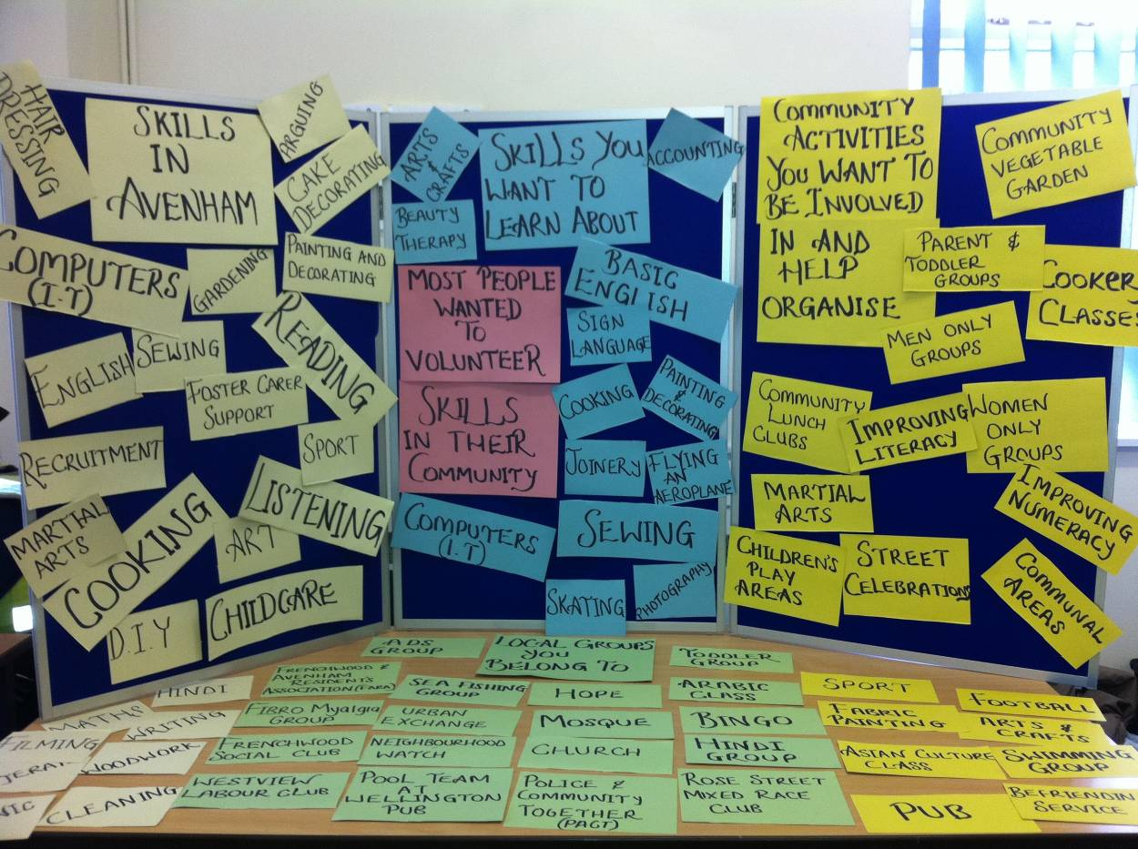

The activities listed as part of the survey drew the following responses.

From the following what would the community want to make use or help organise?
community activity | make use of | help organise | total
Community vegetable garden | 37 | 25 | 62
Parent and toddler group | 15 | 7 | 22
Community Lunch club | 31 | 8 | 39
Gender specific group (men only) | 6 | 1 | 8
Gender specific group (Women only) | 21 | 9 | 30
Didn’t specify male or female only | 16 |  | 16
Improving literacy | 17 | 1 | 18
Improving numeracy | 18 | 1 | 19
Community Film | 0 | 0 | 0
Street celebrations | 45 | 15 | 64
Cookery class | 22 | 8 | 30

Away from the activities the survey directly asked about, many people highlighted the following motivations and issues

- Developing Children’s Play areas
- Disquiet over Cardinal Newman College taking over community buildings
- Parking issues to do with the local college and Town Centre workers
- Neighbourhood security and policing

Detailed results are attached at appendix B (only available on electronic versions)

Foundations and Inn2
The researchers also carried out a survey at Foundations, an emergency and temporary accommodation facility based in Avenham. ‘Foundations’ is a housing project for adults and young people experiencing homelessness, providing short term residency of approximately 1 year. These residents are often marginalised from mainstream community activity, but were happy to engage in this process. The results from the residents at Foundations showed a keenness to participate in activity around the accommodation. Some wanted to gain experience in work related activities such as cleaning the corridors of their living area. Residents at Foundations also had a range of skills to offer, including IT, Cooking Joinery and others.

There was a sense that some residents wanted to participate in generic community activity, but that this would be “in time” and some needed “to overcome anxieties” first. The activities correlated with the popular activities identified by the wider community residents including the community lunch club, vegetable gardens and street celebrations being particularly popular.

7. So what does this tell us?
The survey tells us that there are a range of skills available within Avenham and a large number of people willing to volunteer time and energy to participate in a range of community activities. It also shows some disquiet about certain issues in the area, with the three main ones being the development of the college and its expansion over the area, as well as policing and parking issues. These are items that the community would be likely to get involved with locally, if they felt empowered enough to do so and that there was likely to be changes as a result of their participation.

There are also a significant amount of skills available within the community that could be shared. Use of IT is a skill many people said they had, while many others wanted to learn. Furthermore many residents identified cooking as a skill and this correlated well with the numbers interested in making use of, or helping to organise a community lunch club. The skills available within the community often matched the things people wanted to get involved with, showing that there is potential for the development of existing or new community groups to facilitate these activities.

Many residents felt they wanted to get involved in local community activities but did not feel they knew how to. This shone through in the small amounts of people actively involved in local groups, even though there was significant interest in taking part. The activities that people specified as having an interest in were mainly community based activities and this shows a willingness of the community to participate in these types of activities as well as activities around individual development, such as personal development courses.

Many people expressed an interest in making use of a range of activities, with Community Vegetable Garden, Community Lunch Club and Street Celebrations being particularly popular. Smaller numbers expressed an interest in organising the activities, however there were still significant numbers of people willing to help organise the popular activities as well as people who could be involved in the development of other initiatives.

Residents at Foundations seemed to have low levels of confidence in engaging with community activities, but in the main had a desire to do so. Those that did intimated that they may need support to participate and that short walk in sessions would help.

8. What next?
As a direct action from this report a Community event was held highlighting the following,
- The findings of the survey and what it tells us about Avenham
- What existing projects and groups the community members can get involved in
- How residents can form groups to put on activities or campaign against issues
- Connections with local community officers and professionals
- Living case studies’ of community groups who have achieved some of the similar developments wanted by the community in Avenham.
- Consultation and recruitment exercise for the ongoing development of a local community vegetable garden, which was one of the more popular activities identified in the survey.

The event was attended by local community members and professionals working within the area. It was successful in signing up 8 people to form a local community group to develop and manage a new community garden based in Avenham.

A number of other community members signed up to literacy and numeracy classes and engaged with the different projects on show.

9. Further Recommendations
There are a number of ways of engaging individuals further in community activity. Below are ways in which Avenham residents could be empowered to participate.

- Setting up of a time-banking initiative where residents are able to trade their time and share skills amongst each other. This would enable a systematic approach to sharing skills in the area that people are willing to offer. This would ideally be community led, but would need staff/organisation time initially to develop

- Developing a local small pots funding scheme, allowing community members to fund small community events, activities or initiatives that they are interested in. This could have fairly loose application criteria, enabling the community to concentrate on what is important for them, such as community street celebrations etc.

- Active community members could be identified to act as linkers and gappers, facilitated by local officers such as council neighbourhood renewal officers, local health workers or community police officers. They would be supported to volunteer time within the community to bring skills and motivations together.

- Community led asset mapping to become an annual or biannual process, with community members either involved or leading the process.

- A dialogue with Cardinal Newman College on how best to enable the Avenham community to express their concerns about developments in a constructive way and engage in dialogue.

- Work undertaken to support the development of community groups through local infrastructure development bodies.

- Residents and services users from marginalised communities, such as those at Foundations, assisted to participate in mainstream community activity and being included in community development work in the area. This could be through using additional volunteer support and more engagement activities between the home and the community.

- The community members have shown a commitment to be involved in local community development and they should be empowered to assist and/or lead in local community development projects where possible.

Author: Ismail Karolia (West Lancashire CVS)
Community Researchers: Hayley McGaghey, Kenneth Connelly, Anam Farooq, Kathryn Ettrick (UCLAN foundation degree – Community, Care and Citizenship)

For more information please contact Ismail Karolia at Ismail@wlcvs.org

A community report has also been developed as a briefing for community members and is available to view at appendix C.

References

Department of Communities and Local Government, (2010) Indices of Multiple Deprivation. Found at http://www.imd.communities.gov.uk/ [accessed 8th August 2011]

Improvement and Development Agency, (2010) Glass Half Full: How an asset approach can improve community health and wellbeing, Local Government Association, London. Found at www.idea.gov.uk/idk/aio/18410498 [accessed 6th August 2011]

Kretzman et al, (1997) A Guide to Capacity Inventories, Asset Based Community Development Institute, Chicago

Russell, C (2009) Communities in Control – Developing Assets, Carnegie Trust, Dunfermline. Found at http://www.nurturedevelopment.ie/downloads/Communities_in_Control-DevelopingAssets.pdf [accessed 3rd August 2011]

Appendix A

Avenham Community Mapping

Hello my name is ……… And I’m volunteering with an organisation called Moving On, which is on the corner of Herschell Street and Oxford Road. Moving On is currently involved in support services for people with mental health issues. They are also looking to develop a community garden, where local people can take part in growing vegetables and pick their own vegetables. Since we are new in the area we want to make sure that we know what local community is like before we develop any services. It’s basically about things you would be interested in happening locally and your skills and knowledge, and gaps in the services around here. I have got few questions to ask.
It will take about 5-10 mins, Is that ok?

First Name:

ADDRESS: Postcode:

PHONE: (Organisation):

Email:

LIST BELOW THE ANSWERS YOU GET TO THE FOLLOWING QUESTIONS:

1. What do you do well? For example, cooking, "I'm a good listener," sewing, public speaking, plumbing, etc. (We want to know practical skills and social skills).

2. When you think about all of these skills, what would you say are the ones you are best at or enjoy doing most?

3. Would you be interested in teaching someone else or doing them voluntarily in the community? (i.e. teaching someone carpentry skills; working with a local community group. etc.)

Teaching -

Volunteering –

Appendix A

4. Are there any skills you would like to learn?

5. What are some of the groups you belong to?
( e.g. local faith groups, youth groups, family groups, neighbourhood watch)

6. Do you have a role in these groups?
(Member, Chair, fund-raiser, treasurer, troop leader, etc.)

7. From the following, what are you likely to make use of or help organise

Community activity | Make use of | Help organise | Comments/other
Community vegetable garden
Parent and toddler group
Community lunch club (eat together)
Gender specific groups, (men only or women only)
Improving English
Improving numeracy
Community film
Street celebrations
Cookery classes
Anything else you would like to see or develop?

8. Can we share your information to help organisations to support the community? (e.g. with NHS, Local council, Housing Associations and charities)

Yes No

This inventory was completed by:

Appendix B
Detailed results from the Survey

Appendix C
Community report - distributed at the event to community members

