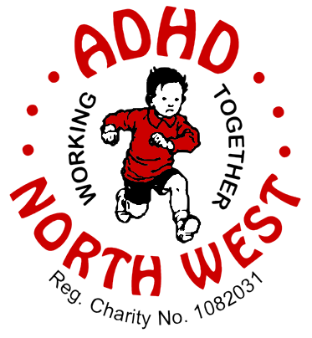
The Lighthouse Care Centre, Townley Street, Morecambe, Lancashire, LA4 5JQ - Tel: 01524 411044
St. James Old School, Cannon Street, Accrington, Lancashire, BB5 2ER – Tel: 01254 352586
email: reception@adhdnorthwest.org.uk

REFERRAL FORM

Date: | Referred by:
Have parent(s) / carer(s) consented to referral YES NO Date of Consent:
Family Address
Postcode |  | Tel: |  | Email
Parent/Carer (1) |  |  |  |  | m / f | Ethnicity
Parent/Carer (2) |  |  |  |  | m / f | Ethnicity
ADHD Child |  |  |  | d.o.b. | m / f | Ethnicity
NHS No. |  |  | GP Practice
Sibling |  |  |  | d.o.b. | m / f | Ethnicity
Sibling |  |  |  | d.o.b. | m / f | Ethnicity
Sibling |  |  |  | d.o.b. | m / f | Ethnicity
Sibling |  |  |  | d.o.b. | m / f | Ethnicity

ADHD Child | Being assessed YES NO |  | Diagnosis YES NO | Medication YES NO
School attended
EHCP? YES NO  Tel: |  | If NO is assessment ongoing? YES NO |  | SEN plan? YES NO
Details of any learning difficulties (e.g. dyslexia, developmental etc.)
Details of additional medical conditions
Details of prescribed medications, learning support, therapy or other support being provided
Details of Services/Agencies involved (e.g. CAMHS, Paediatrics, Social Services, etc.)
Risk assessment completed? YES NO Details if appropriate:
Reason for Referral

