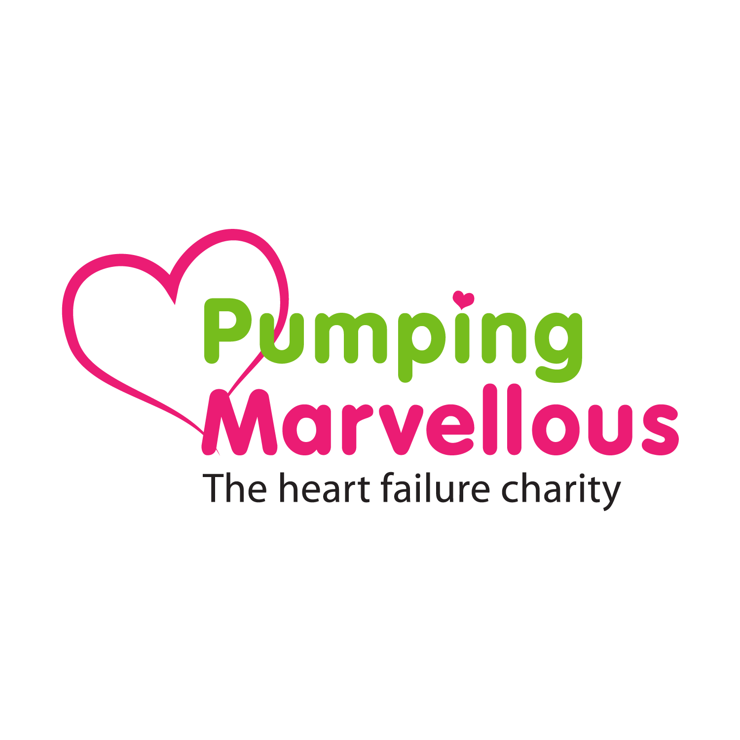
The Pumping Marvellous Foundation ‘Suck-a-Lemon’ campaign 2019!!

It’s Heart Failure Awareness week 6th-12th May and our charity are going ‘all out’ to raise heart failure awareness, & need your help!

Like previous charity awareness appeals, and following the roaring success of our campaign last year, we are asking you and your team to film yourselves marvellously ‘sucking a lemon’ and then post the content to your personal or public social media feeds or broadcast the content live on your outlets.
We would really like it if you could use these lines or similar when taking part:
“We’re/I’m taking the Suck-a-Lemon Challenge for heart failure… because Heart Failure Sucks!!!!!”
See our easy instructions on the next page!
Please ensure to donate £5 or more via Paypal Giving or Facebook and do nominate others to take part.
www.paypal.com/gb/fundraiser/charity/153356 or our Heart Failure Aware page on facebook. www.facebook.com/heartfailureaware
To help us keep track of all of the juicy activities. please use the Hashtags:
#SuckaLemonChallenge #HeartFailureSucks

Thank you once again for taking part,
The Pumping Marvellous team
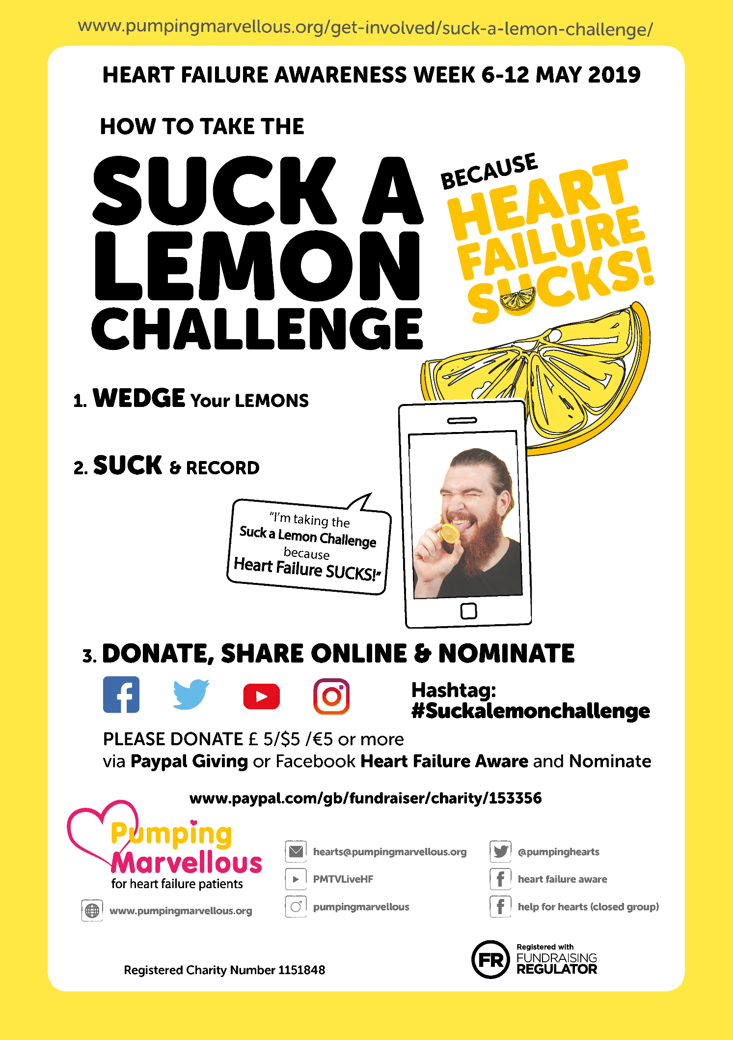
The Pumping Marvellous Foundation, the UK’s Heart Failure charity – Supporting Heart Failure Patients

- 920,000 people have to live with Heart Failure on a day to day basis in the UK.
- One in five people will have to deal with Heart Failure sometime in their lives.
- Heart Failure costs the NHS over £2bn a year.
- Prognosis is worse than most forms of common cancer like breast and prostate cancer.
- Between 30-40% of people die after a diagnosis within 12 months.

It is a debilitating condition that affects all generations. Breathlessness, severe fatigue and swelling are just a number of symptoms which prevent people from working and living their lives normally. It is one of the most underfunded conditions and is a true “Cinderella” syndrome.
Heart Failure is the biggest single cause of hospital admissions in the over 65’s in the UK and sadly the chances of you suffering from Heart Failure in your lifetime increases with age. Over 1 in 10 over 85’s will be Heart Failure Patients and it is prevalent in both men and women almost equally.

The good news is that the Pumping Marvellous Foundation is here. We are the UK’s Heart Failure charity, founded by a heart failure patient, Nick, whose experiences have shaped our goals and principles of a patient-centric charity focused on improving patients’ lives.

Our aim is to help people live better with Heart Failure through helping them self-manage their condition. We are a true patient led organisation where our activities are driven by patient need.

We give Heart Failure patients and their families HOPE.
- HOPE that one day there will be a cure.
- HOPE that they can manage their condition.
- HOPE people managing their heart failure get access to gold standard support & information.

