Communications brief

Blackburn with Darwen, Blackpool and Lancashire Safeguarding Children Boards, and the Pan-Lancashire Child Death Overview Panel, are launching a new campaign which aims to help parents and carers to cope with a crying baby. The call for resources comes from a number of infant deaths and serious case reviews where a baby has died or been seriously injured as a result of abusive head trauma.

Abusive Head Trauma (AHT) – also known as 'shaken baby syndrome' – causes catastrophic brain injuries, which can lead to death, or significant long term health and learning disabilities. AHT is not restricted to specific socio-economic groups – it can occur in any environment, when a parent or carer is on the edge due to infant crying.

The programme – ICON: Babies cry, you can cope – provides key messages and resources to let parents and carers know that infant crying is normal and there are methods which can be taken in order to cope. Resources include leaflets, posters and video clips which can be shared with parents and carers at any contact had with midwives, health visitors, GPs, social workers, and other professionals working with families.

The ICON key messages are:

Infant crying is normal and it will stop
Comforting can sometimes soothe the baby – is the baby hungry, tired, or in need of a nappy change?
It's Okay to walk away if you have checked the baby is safe and the crying is getting to you. After a few minutes, when you're feeling calm, go back and check on the baby;
Never shake or harm a baby; it can cause lasting damage or death
If you need support, speak to someone such as:
your family, friends, Midwife, Health Visitor or GP

The programme will be launched week commencing Monday 29 April, with the release of key messages, distribution of leaflets and posters, pop up stands in birthing centres and hospitals, and bitesize briefings for frontline practitioners.

Please ensure relevant staff are sighted on this campaign and take necessary action to embed the messages in visits with service users.

Day by day:

w/c 22 April | Communication brief out to partners. Including:  - LSCB  - CDOP  - SUDC Prevention  - Agency comms/media Leads
Monday 29 April 2019 | - Website launch  - Partners to share information via internal communication channels  - Begin distribution of hard copy materials  - Social media activity: see plan attached at the end of document
Tuesday 30 April 2019 | - Bitesize Briefings x 3  - Article in local press (date subject to change)  - Pre-record interview with BBC Radio Lancashire  - Social media activity: see plan attached at the end of document
Wednesday 1 May 2019 | - Materials on display in a local hospital for the full week (to be moved around hospitals on a weekly basis)  - Social media activity: see plan attached at the end of document
Thursday 2 May 2019 | - LSCB to promote train the trainer sessions, to:  - LSCB  - CDOP  - SUDC Prevention  - Social media activity: see plan attached at the end of document
Friday 3 May 2019 | - Social media activity: see plan attached at the end of document

Resources:

POSTERS (X3)

Poster 1: | Preview:  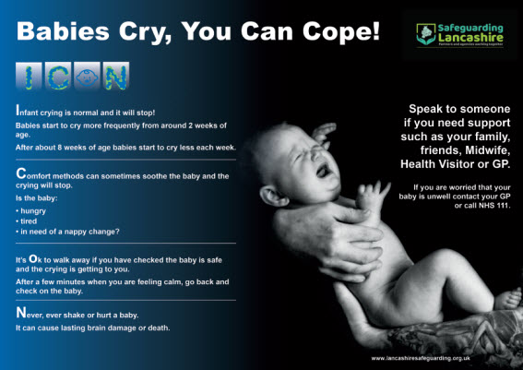

Poster 2: | Preview:  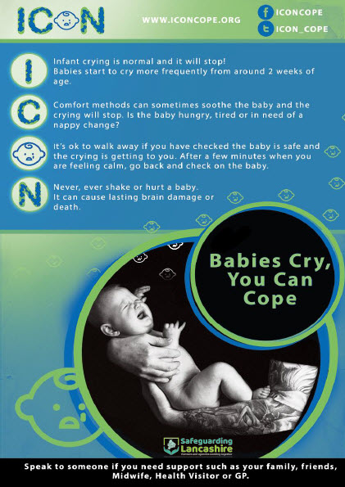
Poster 3: | Preview:  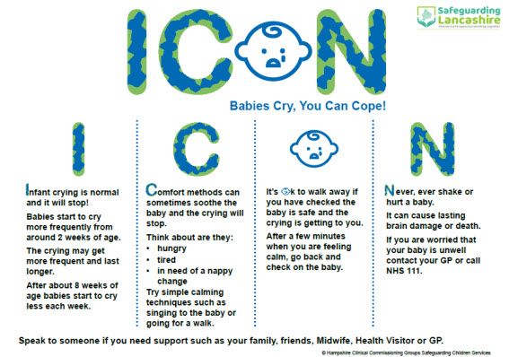

Leaflet:
Print version (A4 Tri-Fold) | Preview:  (Page 1)  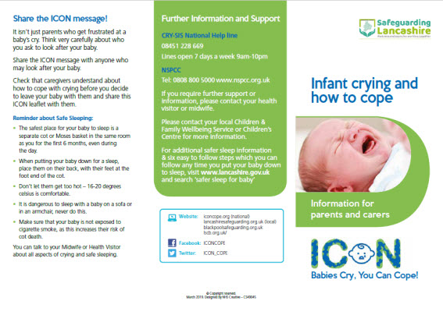
(Page 2)

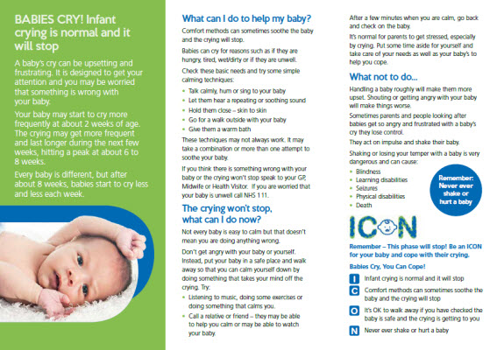

Web friendly spreads: | Preview:  (Page 1)  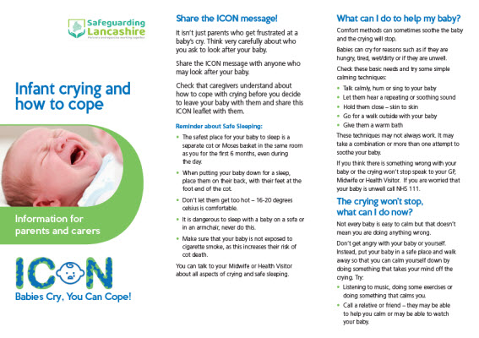  (Page 2)
 | 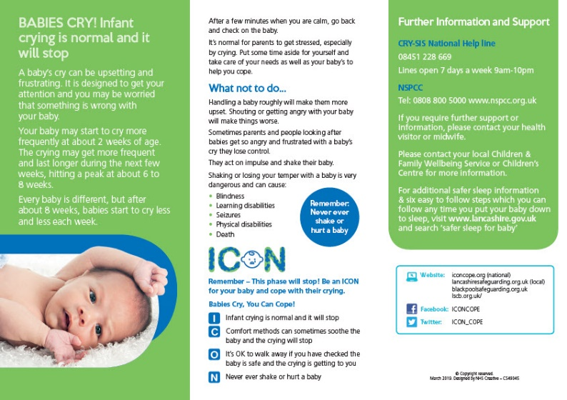

Films (x4):

Film 1:
- Youtube link: https://youtu.be/cCCQi_pRbhY

- Embed code: <iframe width="560" height="315" src="https://www.youtube.com/embed/cCCQi_pRbhY" frameborder="0" allow="accelerometer; autoplay; encrypted-media; gyroscope; picture-in-picture" allowfullscreen></iframe>

Looks like:
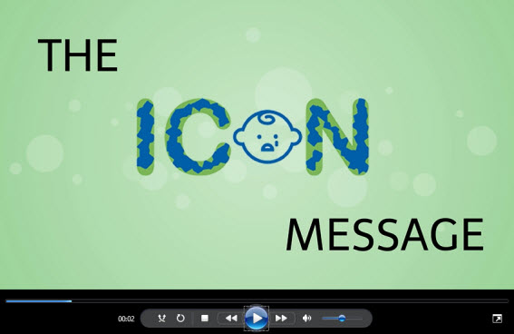

Film 2:
- Youtube link: https://youtu.be/kUqcBQYE3Z8

- Embed code: <iframe width="560" height="315" src="https://www.youtube.com/embed/kUqcBQYE3Z8" frameborder="0" allow="accelerometer; autoplay; encrypted-media; gyroscope; picture-in-picture" allowfullscreen></iframe>

Looks like:
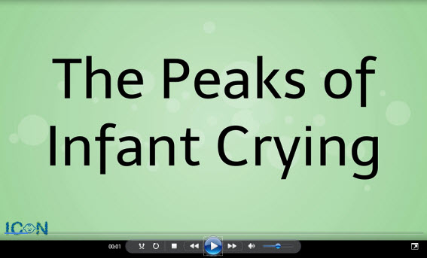

Film 3:
- Youtube link: https://youtu.be/xQai536kp6k

- Embed code: <iframe width="560" height="315" src="https://www.youtube.com/embed/xQai536kp6k" frameborder="0" allow="accelerometer; autoplay; encrypted-media; gyroscope; picture-in-picture" allowfullscreen></iframe>

Looks like:
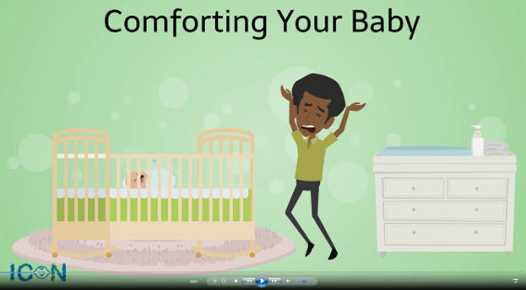

Film 4:
- Youtube link: https://youtu.be/PY8W3QTgS5Y

- Embed code: <iframe width="560" height="315" src="https://www.youtube.com/embed/PY8W3QTgS5Y" frameborder="0" allow="accelerometer; autoplay; encrypted-media; gyroscope; picture-in-picture" allowfullscreen></iframe>

Looks like:
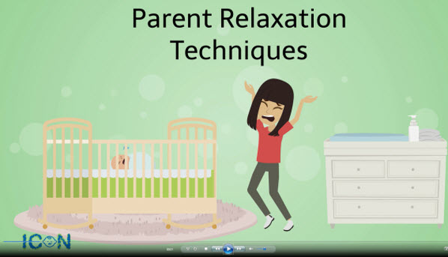

Resources for internal communIcations (in addition to posters, leaflets, films above):

Suggested text for agency communications e.g. team briefs / staff notices / management blogs / websites etc.
A new campaign has been launched to tell parents and carers that infant crying is normal, it will stop, and that they can cope when their baby cries.

Blackburn with Darwen, Blackpool and Lancashire Safeguarding Children Boards have launched the ICON: Babies Cry, You Can Cope campaign following a number of infant deaths and serious case reviews where a baby has died or been seriously injured as a result of abusive head trauma.

Abusive Head Trauma (AHT) – also known as 'shaken baby syndrome' – causes catastrophic brain injuries, which can lead to death, or significant long term health and learning disabilities. AHT is not restricted to specific socio-economic groups – it can occur in any environment, when a parent or carer is on the edge due to infant crying.

Most babies start to cry more frequently at two weeks of age, with crying becoming more frequent and longer lasting during the next few weeks and reaching a peak at six to eight weeks.

The ICON key messages are:
Infant crying is normal and it will stop
Comforting can sometimes soothe the baby – is the baby hungry, tired, or in need of a nappy change?
It's Okay to walk away if you have checked the baby is safe and the crying is getting to you. After a few minutes, when you're feeling calm, go back and check on the baby;
Never shake or harm a baby; it can cause lasting damage or death
If you need support, speak to someone such as:
your family, friends, Midwife, Health Visitor or GP

Visit the campaign website to access the resources and find out more: http://www.lancashiresafeguarding.org.uk/icon.aspx
Opportunity timeline
The attached timeline has been created to highlight to practitioners, the opportunities at which contact with parents/carers can be used to share the ICON messages
Briefing sessions:
Tuesday 29 April x 3 sessions (9.30am to 11.30 / 12.00noon to 2.00pm / 2.30pm to 4.30pm)
Designed to equip frontline practitioners with the knowledge, information and skills needed to discuss the ICON messages with parents and carers. Book now.
Key messages PowerPoint
For delivery in team briefings / meetings:
Banner:
For use on websites or email signatures
Preview:
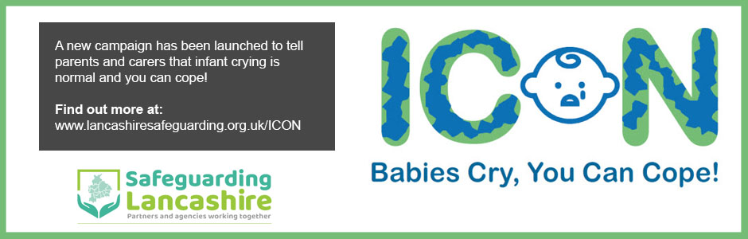

Roll out methods:

Resource | Target | Method of delivery
Leaflet | Parents / Carers | Hardcopy to: Midwives for sharing on discharge from hospital  Electronically: via all partners referenced on opportunities timeline
Poster 1  Poster 2  Poster – ICON Explained | Parents / Carers | Distributed for display in:  - Children's Centres/Children and Family Wellbeing centres;  - CSC family centres;  - YOT Centres;  - Libraries;  - Health settings, e.g.:  - Maternity wards / antenatal waiting rooms  - Birthing centres  - Children's Wards  - A&E  - Walk in Centres  - GP surgeries and Pharmacies (to be targeted as part of phase 2)  - Birth Registration waiting rooms  - Nurseries

Resource | Target | Method of delivery
4 x Video clips | Professionals | Bitesize Briefings on 29 April;  Electronically for team briefs/meetings;  Train the trainer sessions;  Twitter
 | Parents/carers | Bump, Birth and Beyond sessions; during visits with CSC or CFW; Twitter
 | Public | LSCB Website / Twitter
Opportunities timeline | Professionals | Online Toolkit  Bitesize Briefings  Team briefings/meetings/supervision
Key Messages Powerpoint | Professionals | Team briefings and training sessions  Supervision
Website | Professionals  Parents/carers  Public | All resources available online:  www.lancashiresafeguarding.org.uk/ICON
Social Media | Professionals  Parents/carers  Public | Social media plan attached. Please use suggested messages to promote ICON across your social media platforms:

