Health champion “indoor picnic”
12th July 2016, Certacs House, West Lancs CVS
At our “indoor picnic” we did some Ketso (http://www.ketso.com/)

What is Ketso?
Ketso (‘action’ in Lesotho) is a toolkit for giving people space to talk and share ideas in a creative way, using a felt workspace. The photographs below show the Ketso in action.
There were 12 of us altogether during the Ketso.
Our Ketso
At the centre of our workspace we had the health champion role, the ‘tree trunk’. We then had six branches: self, individuals, groups, communicating, connecting and training.

We added four types of leaves to our branches:

- brown (“the soil”) - for ‘brief interventions’ (how had we helped?)
- green (“new shoots”) - for ideas
- grey (“rain clouds”) - for barriers
- yellow - for future goals (what next?)
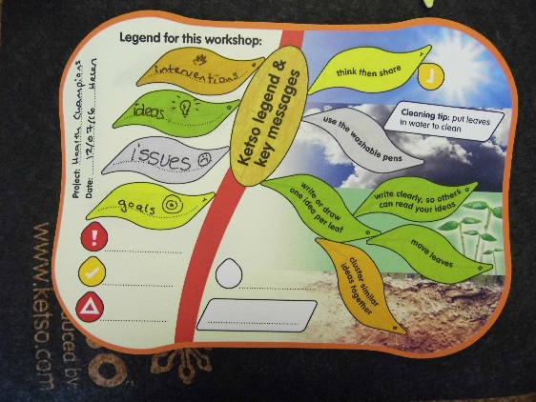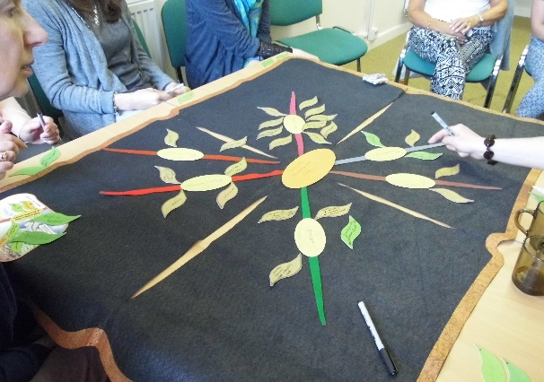
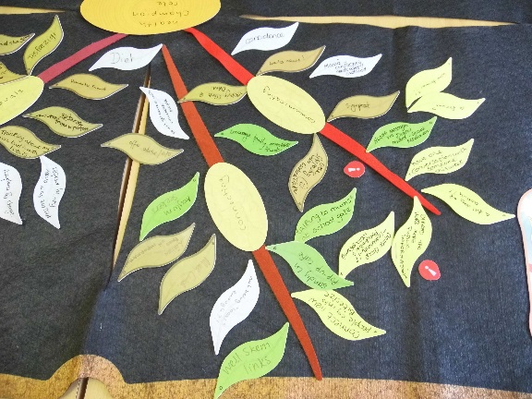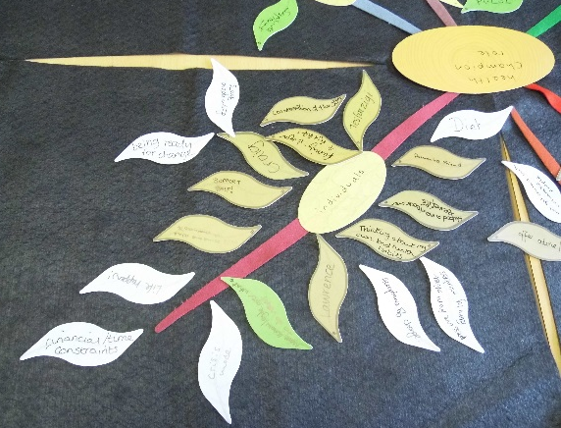

The results
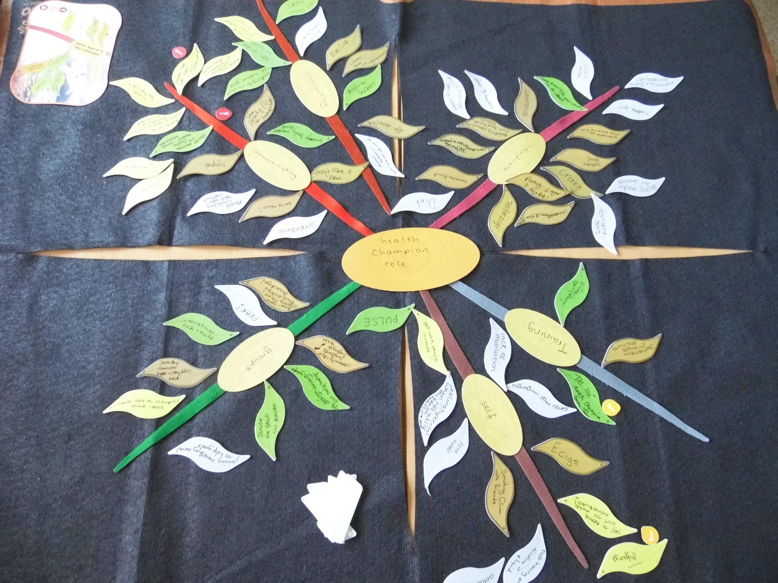
Total ideas | 67
Ideas per participant | 6

What we decided is important:
- Spread the word - more public information (tell people what a ‘health champion’ is!)
- Health messages via digital means, social media etc.

What will move us forward:
- Mindful – think mindfully.
- "Bite size" health champion courses. Step people into the role/the qualification. Taster sessions will make it easier for local people to learn about health and lifestyle change; they allow people to participate and to meet others, creating connections.

The leaves in detail
communicating | 1 How have you helped? (Interventions) | helping clients DAWL
communicating | 1 How have you helped? (Interventions) | reading out the daily health news at work!
communicating | 1 How have you helped? (Interventions) | signpost
communicating | 1 How have you helped? (Interventions) | signposting through Facebook and Twitter
connecting | 1 How have you helped? (Interventions) | mug club
connecting | 1 How have you helped? (Interventions) | listen. Pass on information
connecting | 1 How have you helped? (Interventions) | offer advice, info
groups | 1 How have you helped? (Interventions) | bowel cancer screening project- bowel buddy! Bowel bingo!
groups | 1 How have you helped? (Interventions) | community choir - singing for health
groups | 1 How have you helped? (Interventions) | Divine Days. Timesavers. Puppets and storytelling.
individuals | 1 How have you helped? (Interventions)
individuals | 1 How have you helped? (Interventions) | thinking about my own bad health habits
individuals | 1 How have you helped? (Interventions) | helped a neighbour over benefits
individuals | 1 How have you helped? (Interventions)
individuals | 1 How have you helped? (Interventions) | conversation at the gym
individuals | 1 How have you helped? (Interventions) | family - sugar down - veg & fruit up!
individuals | 1 How have you helped? (Interventions)
individuals | 1 How have you helped? (Interventions) | support, help!
individuals | 1 How have you helped? (Interventions) | told someone about the pharmacist
individuals | 1 How have you helped? (Interventions) | helped a neighbour over benefits
individuals | 1 How have you helped? (Interventions) | dementia friend
self | 1 How have you helped? (Interventions) | smoking clinic with friends
self | 1 How have you helped? (Interventions) | ECigs
training | 1 How have you helped? (Interventions) | Dementia Friends training
! communicating | 2 New ideas? | health message via digital means, social media etc.
! training | 2 New ideas? | "Bite size" health champion courses with Helen
communicating | 2 New ideas? | encourage family members, friends
communicating | 2 New ideas? | talking to mums at school gates
connecting | 2 New ideas? | asylum seekers
connecting | 2 New ideas? | Well Skem links
groups | 2 New ideas? | to design an age group for self help
groups | 2 New ideas? | developing new groups, new activities
groups | 2 New ideas? | Sandy Lane pop-up cafe
groups | 2 New ideas? | International cafe - Concourse
groups | 2 New ideas? | PULSE
individuals | 2 New ideas? | more knowledge over what to do next
training | 2 New ideas? | suicide awareness training
communicating | 3 Barriers? | media - conflicting messages/overload
communicating | 3 Barriers? | confidence
connecting | 3 Barriers? | not being "local" enough!
connecting | 3 Barriers? | do not have contact with vulnerable people
groups | 3 Barriers? | fear! (men - of seeking advice)
groups | 3 Barriers? | joining something social to help goals
individuals | 3 Barriers? | crisis mode - people go back to old behaviour
individuals | 3 Barriers? | financial and time constraints
individuals | 3 Barriers? | life happens!
individuals | 3 Barriers? | being ready for change
individuals | 3 Barriers? | self-medicating
individuals | 3 Barriers? | diet
individuals | 3 Barriers? | pressure from other family members
individuals | 3 Barriers? | acceptance of change
self | 3 Barriers? | lack of motivation
self | 3 Barriers? | motivation other issues
self | 3 Barriers? | feeling hypocritical when not all of my health habits are good
self | 3 Barriers? | fear, worry
self | 3 Barriers? | addictions
self | 3 Barriers? | not having enough nicotine in eliquid
! communicating | 4 Goals - what next? | spread the word - more public information
! self | 4 Goals - what next? | mindful
communicating | 4 Goals - what next? | online group - community i? Facebook? ideas sharing
communicating | 4 Goals - what next? | a full day of activity?!
communicating | 4 Goals - what next? | have one conversation with someone this week
communicating | 4 Goals - what next? | a forum? how formal?
connecting | 4 Goals - what next? | connect new people e.g. into "Bitesize" courses
groups | 4 Goals - what next? | have health champions share ideas
self | 4 Goals - what next? | get more people involved!
self | 4 Goals - what next? | try to reach out to more neighbours!

