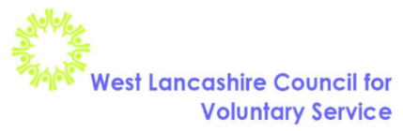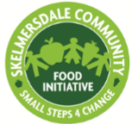
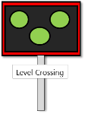
‘Level Crossing’: Helping you to hold a more informed conversation. A community assets approach to promoting self-care for Type 2 Diabetes

Social Media strategy
The social media strategy for the project utilises WLCVS’s position as an infrastructure organisation and, as such, is based on the availability of links to existing West Lancashire Council for Voluntary Service (WLCVS) electronic communications, local Voluntary Community and Faith Sector (VCFS) groups and organisations, network events and other sites of community.

The strategy also acknowledges that social media is only one route to engaging local community in improvements in the uptake of self-care. For example, West Lancashire is predominantly made up of rural hamlets, isolated dwellings and rural villages (‘Rural-Urban definition for Small area Geographies,’ at http://www.lancashire.gov.uk), some parts of which struggle with basic internet access due to gaps in broadband coverage in the wider UK economy and infrastructure. In the borough’s main urban location, Skelmersdale, a digital diagnostic of client's skills carried out by Citizens Advice West Lancashire indicated (2017) that over 18% of residents had never seen the internet. Therefore, at the end of the 18-month phase of “Level Project” (June 2017), “Buzz IT”, a joint initiative of WLCVS and Citizens Advice Lancashire West, was launched to help people with IT skills, including access to digital health, by training and developing volunteer digital champions and buddies located in a new Digital Help Centre next to the Citizens Advice office in the town’s shopping centre (the Concourse).

“Level Crossing” targets the adult population above the age of 40 to match the cohort who have been identified as eligible for free NHS health checks (lancashire.gov.uk/health), specifically people in their 40s and 50s who belong to the target group of the 2016/17 ‘One You’ Public Health England health awareness campaign. Social media sites that tend to be used by a younger population have therefore not been selected (for example 90% of Instagram users are younger than 35 years old: https://www.brandwatch.com/blog/37-instagram-stats-2016/). Instead, a Twitter account was established in line with current WLCVS online communications.

A separate web site name and address has not been created for “Level Crossing” as the project seeks to bring together existing resources and so reduce, rather that add to, the complexity of accessing locally available health interventions. Instead, the project has its own set of pages via the WLCVS website at http://www.wlcvs.org/level-crossing/#tab-id-1. The main website has well-established health pages with a good footfall, and so a web page link for “Level Crossing” fits well into the existing layout.
Current active sites:
As noted above, the West Lancs CVS website at http://www.wlcvs.org/ has well-established Health pages. It has a section with links to “Level Crossing” resources and an overview of the project.
WLCVS also has a Facebook page at https://www.facebook.com/wlcvs/ which runs in parallel with WLCVS’s West Lancs Buzz news portal: http://westlancsbuzz.org/ and Facebook page https://www.facebook.com/wlbuzz/.

The Level Crossing twitter account @levelcrossingwl posts relevant news available on all these sites as well as other information updates around local self-care management and community support. It retweets and is followed by West Lancs Buzz @westlancsbuzz, Active West Lancs @activewestlancs (a partnership including WLCVS Community Food Growing) and another WLCVS project, West Lancs Carers @carerssupportWL.

