“Level Crossing” – improving conversations around health
A selected list of digital sources for staying well with Type 2 Diabetes or to prevent (further) health complications

The following list is a short selection of sources that focus on mental wellbeing, eating well and being physically active. It can be used for general self-care. It is always important to keep in touch with your GP, take up opportunities for medical checks (such as the free NHS Health Check) and screenings, and to follow medical advice.

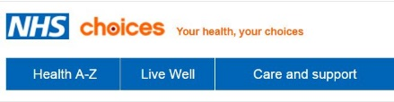
NHS Choices
Click here for NHS Choices. A plain English website with an A-Z list of health conditions and information on available health services. Lots of links to other information.

Interactive Eat Well Plate
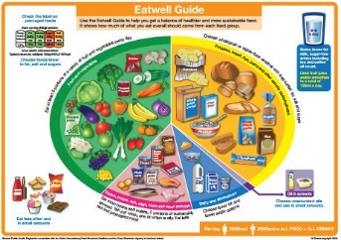
A good ‘all-round’ resource from Public Health England Eat Well Plate. It is available as a simple document. The website gives clear guidance on how to use the Eat Well Plate and a booklet is available online.
(It applies to everyone above the age of two. It is advisable to check with your GP if you have special dietary needs).

BMI checker
This BMI (Body Mass Index) tool to help check whether your weight is healthy for your height. Other tools help with healthy eating and regular physical exercise.
You can also download a free NHS BMI healthy weight calculator and tracker from the iTunes App Store.

Wellbeing self-assessment
The Wellbeing self-assessment tool (via NHS Choices) is a short online quiz that helps you look at how you are doing (mental wellbeing). This is an important part of staying well and being able to manage self-care.

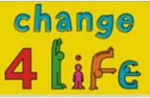
Change 4 Life
Get young members of the family involved: check out the food facts at Change 4 Life . There are also apps for smart phones too.

One You
The One You campaign (Public Health England) is a good source of help and advice. Check out this free app on iTunes and Google Play.
Eating food that has been made at home gives you more control of your sugar, salt and fat intake. See also the Couch to 5K app.

Better Points (Skelmersdale Rewards)
A new phone app (see Better Points) to reward physical activity (walking, cycling, running) with points for vouchers. They can be spent in participating shops or as donations to a local named charity.

“Level Crossing” @levelcrossingwl
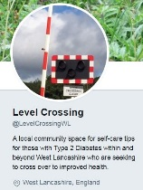
A microblog (Twitter) on health & wellbeing that is local to West Lancashire. The focus is on Type 2 Diabetes, but there is a range of health news and opportunities.
Includes information on local courses on becoming a health champion, being a community connector and using digital resources for health.

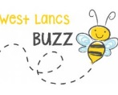
West Lancs Buzz
Check West Lancs Buzz to support your general wellbeing. News of local activity such as groups, health walks etc. Join on Twitter and Facebook to get regular updates.

Diabetes Animation tool
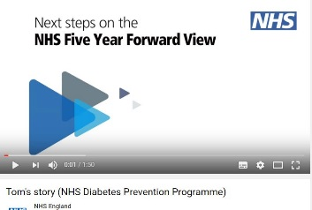
NHS England produced a short animation to mark Diabetes Week 2017. It follows a fictional character’s journey on discovering he was at risk of developing Type 2 Diabetes.

Diabetes UK
Diabetes UK is a key resource for anyone with Diabetes. Look for the organisation’s links to regular information to help you with any management of your condition (once diagnosed by your GP).

