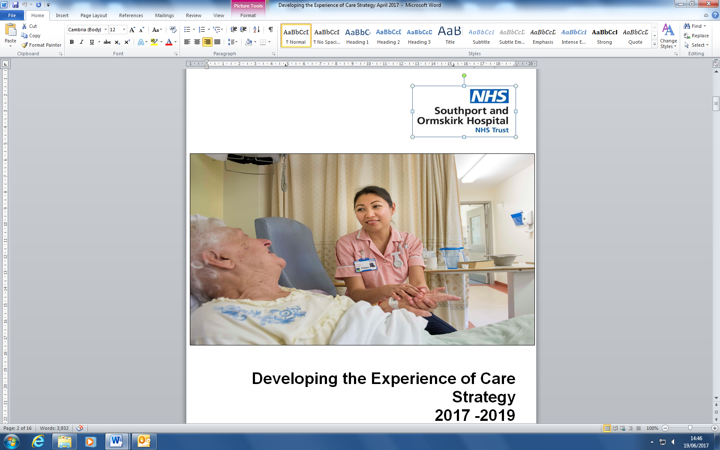

**Developing The Experience Of Care**

Drop by and find out more about our Patient Experience Strategy and the 8 pledges we have made to improve the experience of care at Southport and Ormskirk NHS Trust.

**CARERS CONVERSATIONS**.

Drop in and tell us about your experiences of supporting a loved one at Southport and Ormskirk NHS Trust…



**Wednesday 5th July 2017**

10:30 am-1:30pm Southport District General Hospital Clinical education centre

2:00 pm-4:00 pm Restaurant Ormskirk District General Hospital for coffee chat and Cake

**Thursday 6th July 2017**

10am -3pm

Main Entrance

Southport District General Hospital

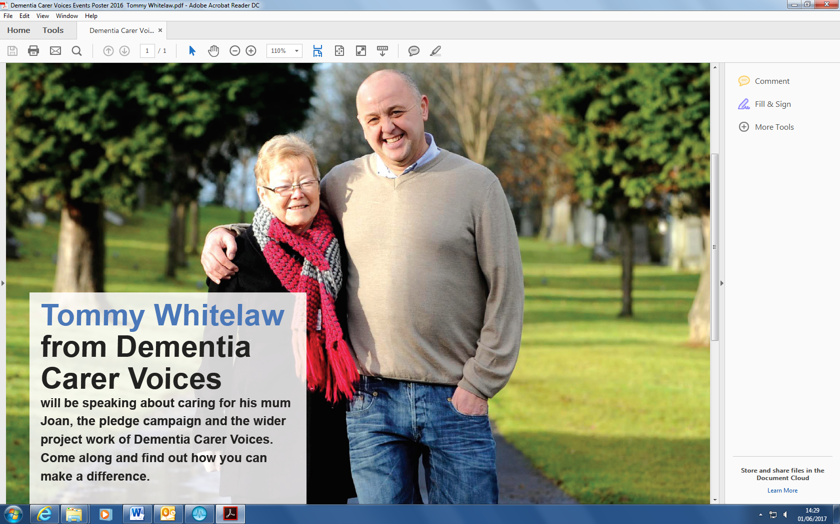

**Monday 3rd July 2017**

10am-12pm or 2.15pm-4pm

Clinical Education Centre

Southport District General Hospital

**Tuesday 4th July ( pm)**

Main Entrance

Southport District General Hospital



Come along and talk to Healthwatch as they will be collecting feedback about the experience of using the services at Southport and Ormskirk NHS Trust.

For further information on the above events please contact Sue Johnson (Tel 704762) [s.johnson12@nhs.net](mailto:s.johnson12@nhs.net) or Michelle Kitson (Tel 704094) [michelle.kitson@nhs.net](mailto:michelle.kitson@nhs.net).

**SOUTHPORT AND ORMSKIRK NHS TRUST**

**CARERS WEEK**

**3RD July – 7th July 2017**

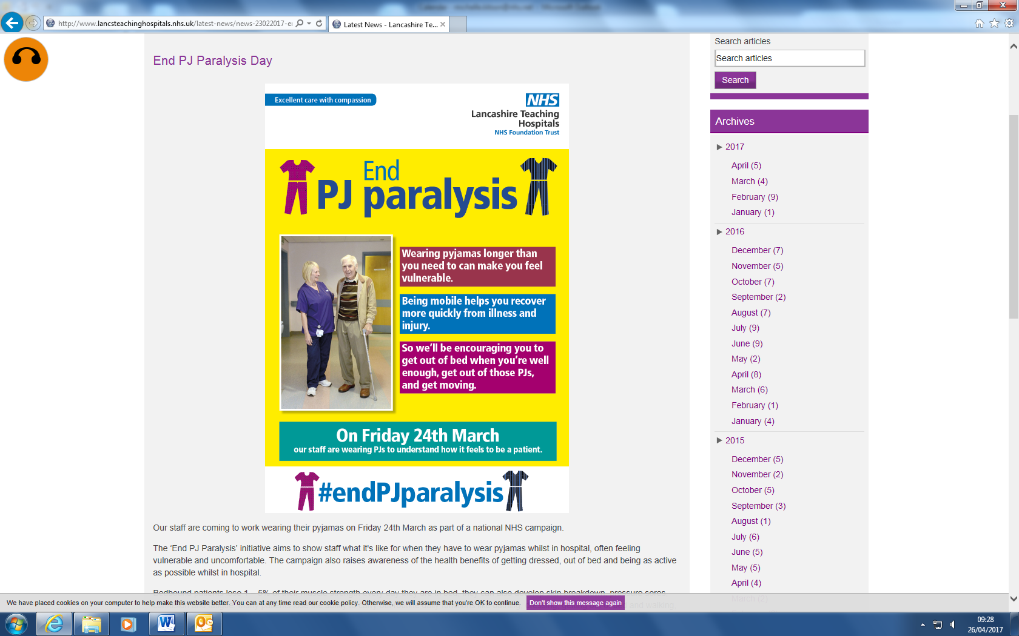

**PATIENTS – GET UP…GET DRESSED…GET MOVING**

**STAFF**- **HELP AND SUPPORT PATIENTS TO GET DRESSED AND GET ACTIVE**

**FAMILY/CARERS** -**PROVIDE CLOTHING, SAFE FOOTWEAR AND ENCOURAGEMENT.**

**Friday 7th July 2017**

There will be staff throughout the Trust educating staff and patients about the benefits of and encouraging patients to get up, get dressed and get moving…..

There will also be an information stand outside the restaurant at Southport DGH.