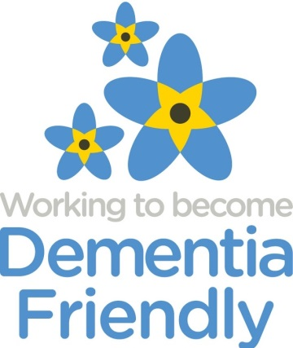West Lancashire Dementia Friendly Communities
2nd October 2017 The Annexe, CLM Church, Cottage Lane, Ormskirk, L39

Present | Initial | Organisations
Kathleen Storton | KS | Alzheimer’s Society
Amanda Boult | AB | Cottage Lane Mission
Robert Godson | RG | Home instead
Carol | CC | RBS manager
Sue Watkinson | SW | U3A
Karen scarbourgh | KS | Lancs fire and rescue
Gayle Woods | GW | Mooney Everett
Pam |  | Mooney Everett
Jon |  | Resident
Apologies
Yvonne Ewes | YE | WLVCS and Carers Support West Lancs
Michelle |  | Southport and Ormskirk hospital

1 | Summary
 | Welcome to new attendees and brief introductions. | KS TO CIRCULATE OLD MINUTES WITH NEW MINUTES
2 | Discussion of event | Action By:
Thanks to all who attended and di their slot in the rain!!
Discussion around the themes that have come from the If only cards.
These were , in general,
Transport – bus drivers could announce, give more time to sit down, the timetable finishes too early.
We discussed approaching Arriva in a formal level seeing what they are involved in already across the region ie DAA/DFC. We also discussed local contact for running a friends session
Shopping – could we have assistance , people stopping in entrance makes it difficult.
We discussed take your time lane and writing to the supermarkets.
Patience- it would help if people didn’t tut at me when im going slow
We discussed a general awareness campaign and how it should be mandatory to have a dementia friends session as part of staff induction
Carers – more groups, more support for carers.
We discussed how we can help raise the profile of groups already out there and then identify any gaps
Another theme that came up in the group discussion is Capacity As a couple of member organisations struggle to support with issues around capacity and GPs assessment, or lack of.
We discussed how GPs could be better supported to better support others.
events
We discussed the business event in October, awaiting to hear from Claire cooper
Amanda and Robert are attending OWLS tomorrow to promote DFC and DF
The group were in agreement to ensure we spread out across the patch and not just focus on west lancs. We will let this pan out how it pans out but for now we want to include all
Nov- sharing of info gathered and action planning - countywide awareness. This will be held at the fire station

L | Meetings and roles | Action By:
We discussed the frequency of meetings and purpose of future meetings.

For now it was decided 6 weekly meetings felt better than monthly or quarterly.
The purpose of the next meeting will be to the nov event planning.
As well as everyone updating on actions
We discussed roles.
It was agreed that we will trail a different chair each time and decide at the end of the meeting for next time.
Robert will chair 13th Nov meeting
Gail and Pam will write up the minutes from that meeting.
Amanda B offered to be press/comms officer
Kathleen will remain the link with Alzheimer’s Society DFC team

6 | Tasks | Action By:
 |  | all
 | AOB
Discussed money and how people have offered us donations on the market stall. KS explained how it would be complicated to go down the bank account route and how we don’t need to really as can rely on members for some things, if we all share it.

Re donations it was decided at the Nov event and any future ones
Each registered charity member could bring their own buckets so it was clear to people where there money was going

Sue is meeting with older peoples champion on Wednesday, will encourage to attend next meeting

Next meeting – 13th nov 1pm cottage lane mission

