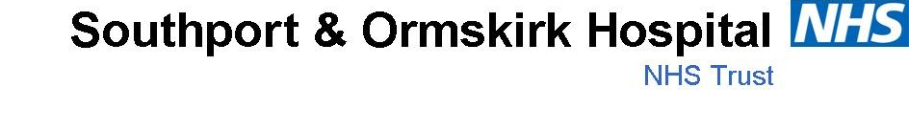
Course: Level 2 Stop Smoking Advisor

This training is provided free by West Lancashire Stop Smoking Service (WLSSS) and you will be provided with the materials you need to deliver stop smoking support to your clients.
Anyone who would like to attend the 2 day training should be in a position to
- Provide a structured 12 week programme of stop smoking support to clients/service users
- Send accurate 4 week outcome monitoring information to the Quit Squad (Stop Smoking Service) to contribute to the 4 week quit targets reported to the DoH.

Level 2 Advisor Stop Smoking 2 Day face to face training- this is organised and provided by the West Lancashire Stop Smoking Service.

10 Hours Shadowing – you are required to travel to a WLSSS Clinic of your choice to complete the shadowing
You are also required to complete the following online modules. These modules have been developed by the National Centre for Smoking Cessation Training to ensure all advisors are trained to the same high standards.
NCSCT Very Brief Advice - ideally completed prior to attending the 2 day training

NCSCT Second Hand Smoke - ideally completed prior to attending the 2 day training

NCSCT Level 1

NCSCT Level 2 (late 2014 Level 1 and 2 will be amalgamated to form one full certificate)
Any of the other NCSCT relevant to post for example
NCSCT Smoking in Pregnancy
NCSCT Smoking and Mental Health
You are also required to attend 2 update events per year. These events are usually held in an evening and allow best practice updates, new product information and an opportunity to network with other advisors in the area.

Programme
Day 1

9:00 AM Registration
9:30 AM Introduction and Smoking Quiz
The National and Local Context
Why People Smoke and Barriers to Quitting
Components of a Cigarette and Nicotine Addiction
Assessment of Nicotine Dependence
Nicotine Replacement

Lunch

1:30 PM Stages of Change Model
Raising the Issue
Motivational Interviewing
Practical Exercise
Relapse Prevention
Raising the Issue – Homework

Day 2

9:00 AM Registration & Level 1 NCSCT Training feedback
9:30 AM Co Monitoring (Practical)
Niche Tobacco Products
Alternative Therapies
Record Keeping/monitoring/resources
NRT Voucher Scheme
Varenicline

Lunch

1:30 PM Varenicline Paperwork
Bupropion
Treatment Toolkit
Practical Practice/Case Studies
NCSCT Information – specialised Modules
Shadowing Details
Local Services Timetable
Evaluation – Survey Monkey

Objectives
- Be aware of the programme of study and your responsibilities
- Understand the patterns and prevalence of smoking
- Have a background knowledge of legislation and government action around smoking
- State why smoking is unhealthy
- State the main chemicals found in cigarette smoke
- Be aware of the main factors around nicotine addiction and withdrawal
- Be able to use a simple tool to measure nicotine dependence

Objectives
- Be aware of the cycle of change and its application to behaviour
- Have an awareness of strategies used in relapse prevention
- Be able to communicate effectively and aware of the importance of setting
- State the importance of accurate record keeping

Aims and Objectives
- Demonstrate the use of a carbon monoxide monitor
- Be aware of alternative therapies
- Show and understanding of record keeping and the Russell Standards
- Have confidence to deliver treatment regimes effectively
- An understanding of Niche and Illegal Tobacco

Further Resources and Training
- Shadowing details – 10 hours with specialist advisor – drop- ins
- Time table – local service
- Evaluation
- Treatment toolkit
- NCSCT – You will not be signed off unless you have completed full certification.

Unfortunately we are not in a position to provide lunch but the hospital canteen will be available on both days.

