 | Cumbria & Lancashire Team  Level 1, York House  Ackhurst Business Park  Chorley  Lancashire PR7 1NY |  | T +44 (0)344 225 0602  F +44 (0)1257 246451  www.gov.uk/phe

27 January 2016

To whom it may concern

Re: Zika Virus

Zika virus (ZIKV) is transmitted by the bite of an infected female Aedes mosquito, most commonly Aedes aegypti. The Aedes mosquito is not present in the UK and is unlikely to establish in the near future as the UK temperature is not consistently high enough for it to breed.

Whilst almost all cases of Zika are acquired via mosquito bites, a small number of cases have occurred through sexual transmission or by transmission from mother to foetus via the placenta. If a person acquires Zika abroad and becomes ill on their return to the UK, mosquito-borne transmission will not occur as the mosquito is not present. More information on ZIKV is available on PHE and WHO websites.

There are on-going outbreaks of ZIKV in South and Central America and the Caribbean. More information of affected countries is available on the ECDC and WHO websites.

A probable association of ZIKV infection with congenital microcephaly is currently being investigated.

Advice on the management of pregnant women exposed to ZIKV is available from the Royal College Obstetricians & Gynaecologists. Travel advice for pregnant women is available from the NaTHNac website.

Diagnosis

Consider ZIKV among the differential diagnoses of patients with fever returning from South and Central America, the Caribbean, Africa, South and South East Asia and the Pacific region.

For suspected ZIKV cases, contact your local infection doctor (Infectious Disease specialist, Microbiologist or Virologist). If testing for ZIKV is being considered, please contact the Imported Fever Service (IFS). The IFS can be reached 24 hours a day on 0844 7788990. Appropriate samples (with a full clinical and travel history) will need to be sent to PHE’s Rare and Imported Pathogens Laboratory (RIPL).

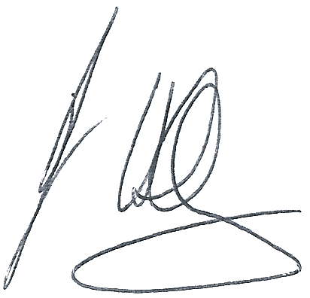
Yours sincerely

Dr John Astbury
Consultant in Health Protection

